**Smart Assistant For Public Parks Using IBM Watson**

# INTRODUCTION:

## Overview:

Nowadays the Technology is being very famous for the User Experience ,because it is very easy to access the applications and services from any where of your Geolocation.

For an instance the most famous application of iphone is "SIRI" which helps the enduser to communicate end user to mobile with voice,it makes the end user work easier than rather,so by using this voice assistant we can make the crowdy area like enquiry places to smart enquiry,which makes the work faster than making one person to sit at the enquiry place and creating the crowd.so we are proposing a system at an public parks.

## Purpose:

The Purpose of our system is to create a smart voice assistant for public parks using IBM Watson,Where we can search for the information related to park,the information like park opening timings at the morning ,closing timings at the evening,entrance cost for an particular park and parking cost ,etc.in that particular smart assistant

We make this several smart assistant available at the outside of the parks which can help the user to get the information what they want to know

# LITERATURE SURVEY

## :Existing problem:

We are still far away from understanding the genuine capability of speech recognition technology**,**Voice recognition technology was around some time before Apple's Siri appeared in 2011. At the Seattle World's fair in 1962, IBM presented a device called Shoebox.It was the size of a shoebox and could perform scientiﬁc functions and perceive 16 spoken words as well as digits 0-9. Mozilla are working on foundations for open, public voice services. Training a voice assistant takes a lot of data though: 10,000 hours of recordings. To put that in context, the total of all of the TED talks out there comes to about 100 hours: still 2 orders of magnitude away! That’s why IBM Watson have opened up Project Common People can allow to lend their own projects and voices. And they have been starting to explore the idea of open voice service registration under a preliminary name of Watson Assistant.

## Proposed Solution:

Keeping the open technology created by IBM in mind ,we applied the smart Assistant to the real world ,to conﬁne the problems that are facing at the crowdy area,if we implement that assistant in this kind of problems,we can make the man work a bit easier than earlier.

So we proposed an solution with watson assistant ,so if we deploy the several assistant at the public places like parks,it creates an impact for the other language tourist to know the information conviently.

# THEORITICAL ANALYSIS

## Block Diagram:

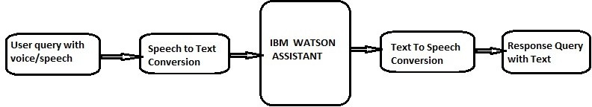

* 1. **Hardware/Software Designing:**

## Software Designing:

* + - code for Text To Speech
    - code for Speech To Text
    - code for Watson Assistant

# EXPERIMENTAL INVESTIGATIONS

Intially we start by creating the chatbot using "watson assistant" by IBM,we train the chatbot with all the questions that can user ask,we gave the answers related to the questions,Following is the picture of service we used to create an Chatbot

But our project is to control the bot using the voice,so we use the service called as "Speech-To-Text",Which converts the user query to text and give the text to the chatbot,the following is the picture of service we used to Convert

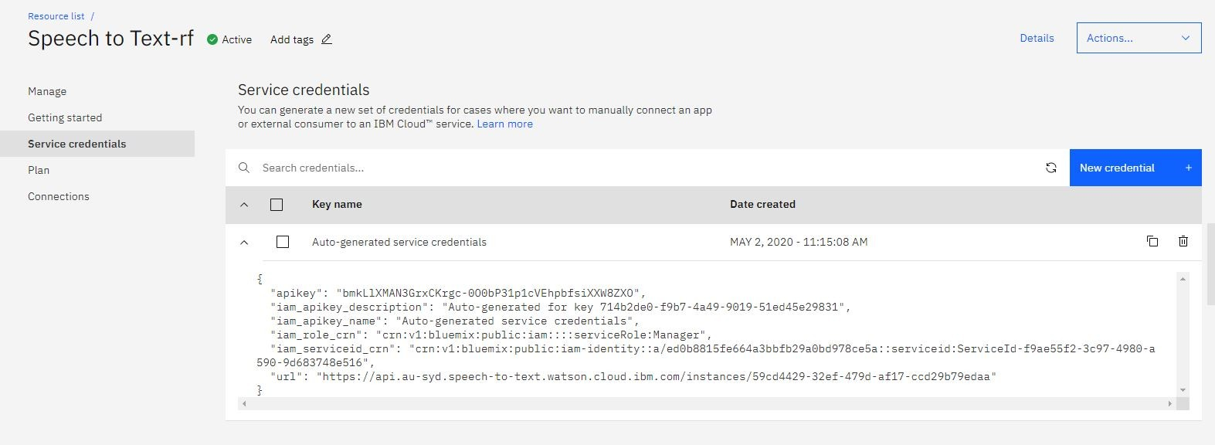

Now we get an output in an text form but we want to to get it in speech ,So we used an service called as "Text-To-Speech",which converts the text from the chatbot to the speech form ,following is the picture of service we used to Convert

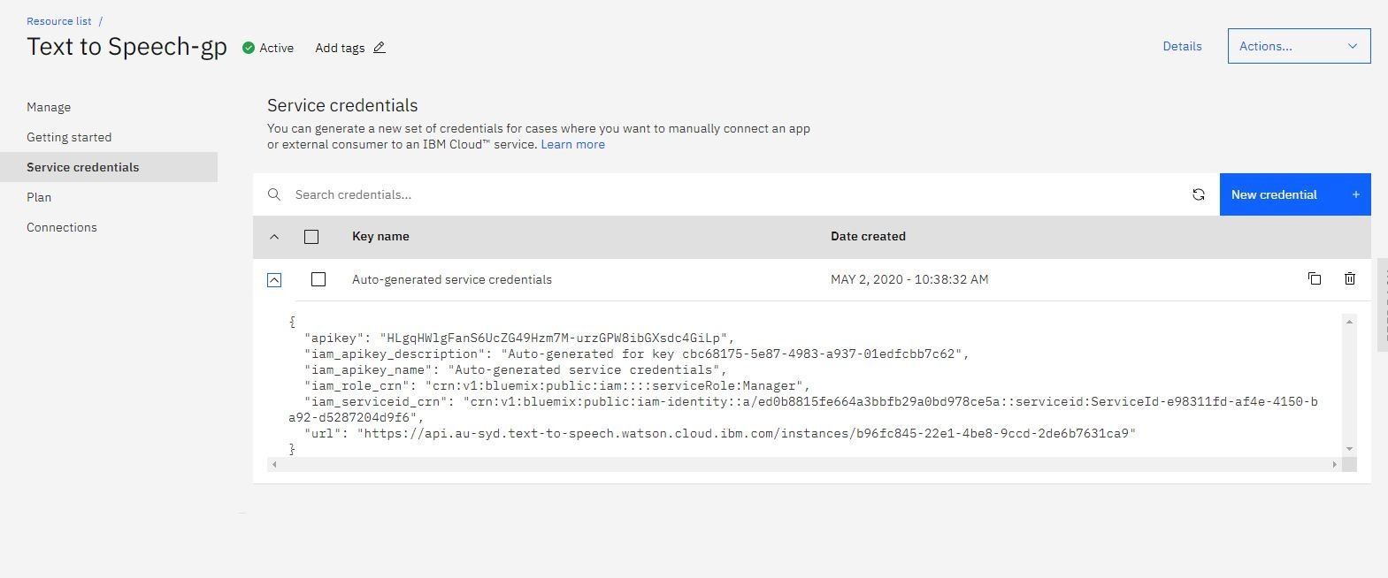

we interlinked all things,but the user need to understand all these,so we had created an UI(user interface)in which the user press an button ask their query and it proccess and gives an reply to user,For this we used an "NODE-RED",This service provides an UI for the projects we done,following is the picture and example if user ask query and answer in form of text(due to picture we cant integrate an voice)

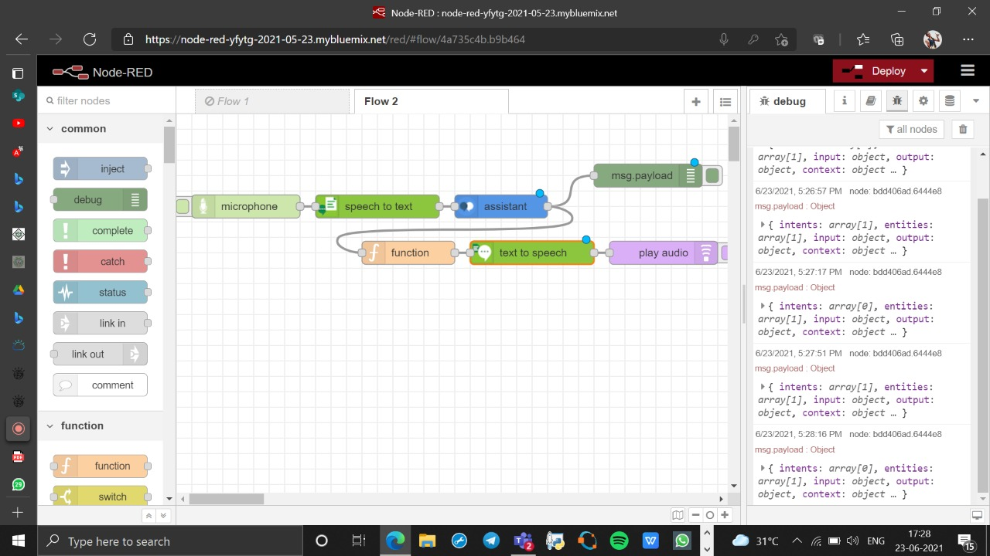

We worked with python code also if user gave input using that code,it generate a session and it pass the information to the chatbot with python code itself and it gets output and play it in the terminal/shell of the python ,the following code is given in the Appendix.

# FLOWCHART:

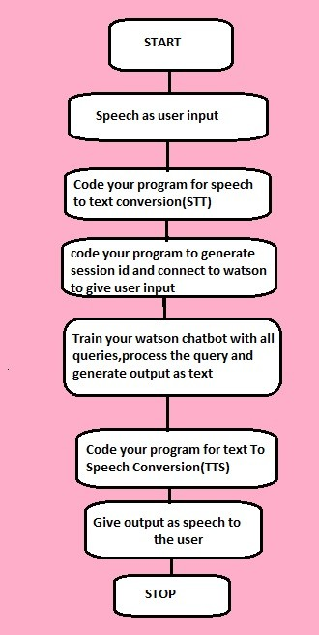

1. **RESULT:-**

Using the proposed system the results observed are smart asssistant for parks using IBM Watson helps the park commitee very well,getting free from unknown language vistors to their parks asking different kind of questions,they can replace their enquiry booth with these smart assistant UI that we developed.

NODE-RED(UI output)

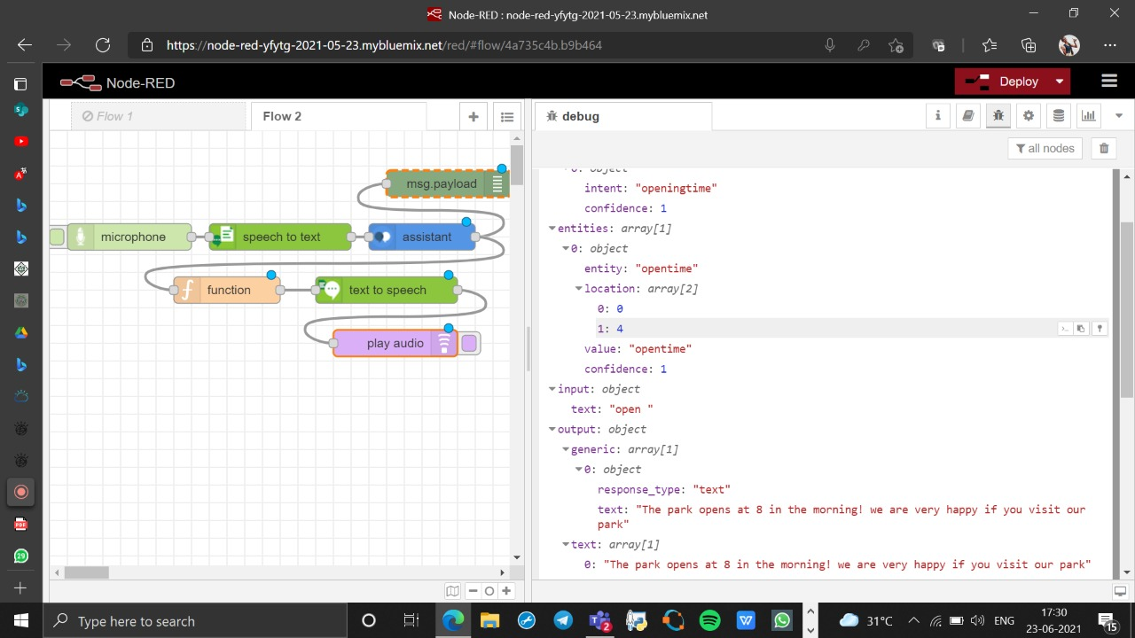

# ADVANTAGES & DIS-ADVANTAGES:

## Advantages:

* Help you to save time
* Streamline communication with foreigners
* VUI Technology is Evolving
* Help users that suffer from where to know information

## Dis-Advantages:

* Smart Home Devices are Expensive
* voice recognisation isn't perfect
* Human to Human interaction may be lost

# APPLICATIONS:

These voice assistant can be used in

* Enquiry at outside the park
* used inside the park to know the directions
* used to know total information related to a new place
* used at railway stations to know information without standing for longtime in lines
* used in the bus stand to know the furter bus timings

# CONCLUSION:

Voice assistant provides hands-free experience to answer the quick queries or ﬁnd park information or urgent information of a particular park. Thus our web application would be helpful for new users as well as people with hectic schedules.Our web application improves upon the current state of the art by increasing user satisfaction and convenience.

# FUTURE SCOPE:

♢ We are trying to extend our project to deploy inside an park also to know the directions and locations of hotels and canteens inside an park

♢ we are trying to integrate this inside an railway station at the enquiry point ,it will help the railway comitee alot

♢ By creating an individual apks for respective places contains an detailed information which can be controlled by using voice commands.

# BIBILOGRAPHY:

1**.**

[https://cloud.ibm.com/apidocs/assistant/assistant-v2?code=python#send-user-input-to-as](https://cloud.ibm.com/apidocs/assistant/assistant-v2?code=python&send-user-input-to-assistant-stateful) [sistant-stateful](https://cloud.ibm.com/apidocs/assistant/assistant-v2?code=python&send-user-input-to-assistant-stateful)

2.<https://cloud.ibm.com/apidocs/speech-to-text?code=python> 3.<https://cloud.ibm.com/apidocs/text-to-speech?code=python>